ASSIGNMENT
Motion in a straight line
- State the condition when the magnitude of velocity and speed of an object are equal.

- Under what condition will the distance and displacement of moving object have the same magnitude?

- Which vector can be associated with a plane area? And what is its direction?

- Can the relative velocity of two bodies be greater than the absolute velocity of either?

- When a body accelerates by at, what is the velocity after time ‘t’ when it starts from rest?

- Write the expression for distance covered in n^{th} second by uniformly accelerated body.

- The position -time (x-t) graphs for two children A and B returning from their school o to their homes P and Q respectively are shown in figure .Choose the correct entries in the brackets below:
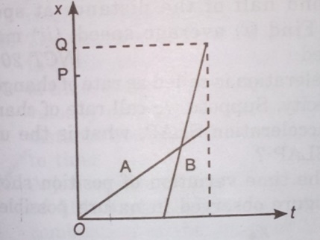
- The length covered by a body is found to be directly proportional to the square of time .
What is the nature of acceleration?

- A car starts accelerating from rest for sometime, maintains the velocity for sometime and then comes to rest with uniform deceleration .Draw the u-t graph.

- The two straight rays OA and OB on the same displacement -time graph make angle 30 and 60 with time axis respectively as shown in figure.
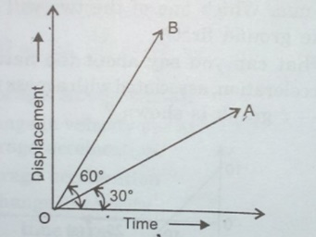
- A body goes from A and B with a velocity of 40 m/s and come back from B to A with a velocity of 60 m/s.What is the (1) average velocity during the whole journey and (2) average speed during the whole journey?

- An object moving on a straight line covers first half of the distance at speed u and second half of the distance at speed 2u find (1) average speed ,(2) mean speed.

- A ball is thrown vertically upwards. Draw its:
- Velocity-time curve
- Acceleration-time curve.
- A body starts from rest and moves along a straight line .It has uniformly accelerated motion up to time t₁ During the interval t₂-t₁ it moves with uniform velocity .After time t₂ its motion is retarded , and it comes to rest at time t₃. Draw the velocity-time graph
.
- A jet aeroplane travelling at the speed of 500 km h ⁻¹ ejects its products of combustion at the speed of 1500 kmh⁻¹ relative to the jet plane. What is the speed of the latter with respect to an observer on the ground ?

- The velocity of particle is U= 5+2(a₁ +a₂t) where a₁ and a₂ are constants and t is the time . What is the acceleration of the particle ?
- Two balls of different masses are thrown vertically upwards with same initial speed. Which one will rise to the greater height ? Which of the two will come back with greater speed to the point of projection ?
- What is the position at any time ,for a body starting from rest, with an acceleration a=at² ?

- Two parallel rail tracks run north – south .Train A moves due north with a speed of 54 km h⁻¹ and train B moves due south with a speed of 90 km h⁻¹.What is the relatives velocity of B with respect to A m s⁻¹ ?
- The driver of a truck travelling with a velocity u suddenly notices a brick wall in front of him at a distance d. Is it better for him to apply brakes or to make a circular turn without applying brakes in order to just avoid crashing into the wall? Why?

- The distance x travelled by a body in a straight line is directly proportional to t². Decide on the type of motion associated. If x$∝$ t³ what change will you observe ?

- A body starting from rest accelerates uniformally along a straight line at the rate of 10 ms⁻² for 5 seconds. It moves for 2 seconds with uniform velocity of 50 ms⁻¹.

- (a) With the help of a simple case of an object moving with constant velocity show that the area under velocity -time curve represents the displacement over a given time interval.
(b)Establish the relation
X=u_{o} t + ½ at² graphically.
(c)A car moving with a speed of 126 km/h is brought to a stop within a distance of 200 m.
calculate the retardation of the car and the time required to stop it.
- Draw velocity -time graph of uniformly accelerated motion in one dimension.From the velocity time graph of uniform Then it retards uniformly and comes to rest in 3s.Draw velocity -time graph of the body and find the total distance travelled by the body.

- The displacement (in metre) of a particle moving along x-axis is given by
x=18 t + 5 t².Calculate :
- The instantaneous velocity at t=2s,
- Average velocity between t=2s and t=3s, and
- Instantaneous acceleration.
- Derive an equation for the distance covered by a uniformly accelerated body in n^{th} second of its motion. A body travels half its total path in the last second of its fall from rest . Calculate the time of its fall.

- Two trains each having a speed of 30 km/hr are headed at each other on the same track.A bird that can fly at 60 km/hr flies off from one train ,when they are 60 km apart, and heads directly for the other trains. On reaching the other train ,it flies directly back to the first ,and so forth.
- How many trips can the bird make from one train to the other before they crash ?
- What is the total distance the bird travels ?
- A trains starts from a station P with a uniform acceleration a₁ for some distance and then goes with the uniform retardation a_{2.} For some more distance to come rest at the station Q. The distance between the stations P and Q is 4 km and the train takes 4 minutes to complete this journey .If accelerations are in km per min².
Show that 1/a2 +1/a2=2.
- A body moving with a uniform acceleration describes 12 m in 3ed second of its motion and 20 m in the 5th second . find the velocity after 10 seconds.
- The speed of a train increases at a constant rate $α$ from zero to µ and then remains constant for an interval ,and finally decreases to zero at a constant rate $ᵝ .$If L be the total distance described prove that the total time taken is
L/U +U/2 (1/α+1/ᵝ).
- A car travels first half of a length S with velocity u1. The second half is covered with velocities u2 and u3 for equal time intervals.Find the average velocity of the motion.

- A body start from rest and accelerates uniformly .find the ratio of the displacement in, (1)one, two and three seconds, (2) first ,seconds and third second.

- A moter boat covers the distance between two spots on the river in time of 8 hrs. and 12 hrs. downstream and upstream respectively .What is the time required for the boat to cover this distance in still water?

- A body covers 12 m in 2nd seconds and 20 m in 4th sconds .find what distance the body will cover in 4 second after 5th second.
- Read each statement below carefully and state with reasons and examples, if it is the or false : A particle in one -dimensional motion
- With zero speed at an instant may have non-zero acceleration at that onstant
- With zero speed may have non-zero velocity,
- With constant speed must have zero acceleration,
- With positive value of acceleration must be speedind up.
- On a long horizontal moving belt,a child runs to and fro with a speed 9 km h⁻¹ (with respect to the belt) between his father and mother located 50 m apart on the moving belt .The belt moves with on the moving belt.The belt moves with a speed of 4 km h⁻¹ For an observer on a stationary platform outside ,what is the
- Speed of the child running in the direction of motion of the belt ?
- Speed of the child running opposite to the direction of motion of the belt?
- Time taken bye the child in (a) and (b)?
- On a two lane road , car A travelling with a speed of 36 kmh-1.Two cars B and C approach car A in opposite directions with a speed of 54 kmh-1 each .At a certain instance ,when distance AB is equal to AC ,both being 1 km, B decides to overtake A before C does. Wthat minimum acceleration of car B is required to avoid an accident ?
- Two towns A and B are connected by a regular bus service with a bus leaving in either derection every T minutes. A man cycling with a speed of 20 kmh-1 in the direction A to B notices that a bus goes past him every 18 minutes in the direction of the motion, and every 6 minutes in the opposite direction . What is the period T of the bus service and with what speed (assumed constant) do the buses ply on the road ?
- The velocity -time graph of an object moving along a straight line is as shown.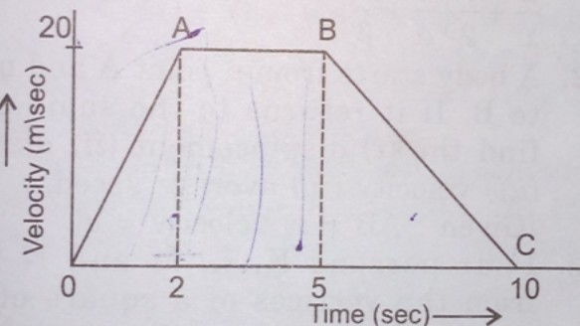
- Two trains A and B of length 400 m each are moving on two parallel tracks with a uniform speed of 72 kmh-1 in the same direction , with A ahead of B. The driver of B desire to overtake A and accelerates by 1 ms-2 .If ,after 50 s, the guard of B just brushes past driver of A, calculate the original distance between the two trains.
- The displacement -time graph of two bodies P and Q are represented by OA and BC respectively. What is the ratio of velocities of P and Q ?
^{<OBC=60 and <AOC=30}
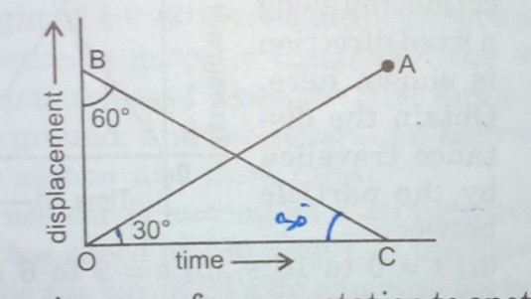
- A man walks on a straight road from his home to a market 2.5 km away with a speed of 5 km/hr. Finding the market closed ,he instantly turns, and walks back home with a speed of 7.5 km/hr. What is the (a) magnitude of average velocity and (b) average speed of the man over the interval of time
- 0-30 minutes (2) 0-50 minutes (3) 0-40 minutes?
- A body is moving with a uniform acceleration .its velocity after 5 seconds is 34 m/s. Calculate the distance it will cover in 10th second.
Two cars , A and B are travelling in the same direction with the velocities ua and ub respectively . When the car A is at a distance d ,and behind the car B the brakes are applied on A ,causing a deceleration
(45)Identify the type of motion in the following case:
