BEATS_
If two tuning fork whose frequency is slightly different are sounded together , the sound we hear periodically fluctuates in intensity , i.e intensity increases and decreases suddenly . This periodic variations in intensity of sound are called beats.
So we can define “ Beats are periodic vibration in the intensity of sound when two sound wave of nearly same frequency travel in the same direction. One loud sound followed by a faint sound from one beat and the number of beats formed per second is called beat frequency.
Graphical method for the formation of beats-
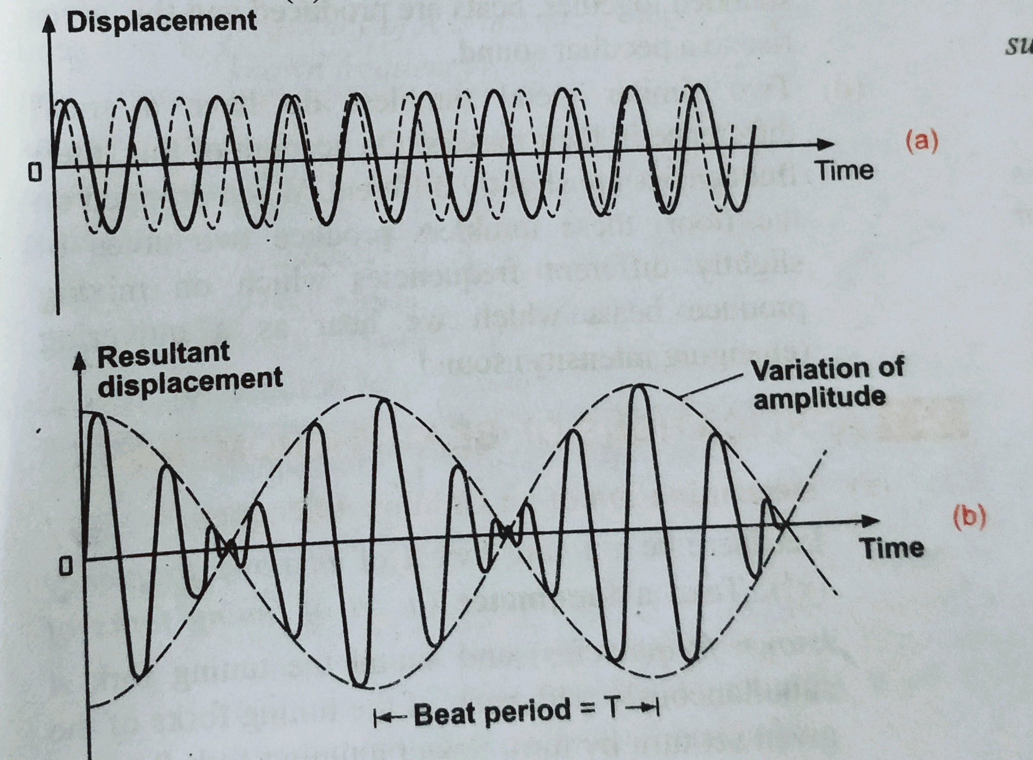
As shown in fig (a) Two waves ( One in dotted and other in dark line). When they superimpose then due to the superposition principle , at T=0 the intensity becomes max and at T= T/2 Intensity becomes minimum which is ‘0’ . This process happening again and again.
And number of beats per second or beats frequency is equal to difference in frequency between these two waves.
Suppose the beat period is T and that during this time one wave of frequency n₁ , makes one cycle more than the other wave of frequency n₂ . The number of cycle of frequency n₁ in time T = n₁T. And number of cycle of frequency n₂ in time T = n₂T.
According to the given condition, n₁T-n₂T = 1
Or
n₁-n₂ = 1/T = n₀ (resultant frequency).

Analysis of graph shown in figure-
(1)The resultant wave oscillates with the average of the frequencies of the individual waves .
(2) The resultant amplitude oscillates with a beat frequency that is equal to the difference between the two frequencies.
Application of beat phenomenon
(i) Determination of unknown frequency
(ii) By loading tuning fork with wax.
(iii) By loading the tuning fork
(iv) Tuning musical instrument
(v) In electronics

